COMP 3710 Artificial Intelligence
Final test – Fall 2013
Total 77 marks

Student Name: Student Number:

- (2 marks) List 10 important AI topics that we have discussed in this term.

- (5 marks) Consider the 3 missionaries and 3 cannibals problem: Three cannibals and three missionaries must cross a river. Their boat can only hold two people. If the cannibals outnumber the missionaries, on either side of the river, the missionaries are in trouble (I won't describe the results). Each missionary and each cannibal can row the boat. How can all six get across the river?
- Design a suitable representation (i.e., states) of the problem with a brief explanation.

- Give the initial state and the goal state.

- Give all the possible next states after the initial state.

- Explain what a solution of this problem is.

- Explain how you can find a solution of this problem.

- (2 marks) Define what an A* algorithm is.

- (2 marks) Can you use an A* algorithm to solve the n queens problem in which n queens should be placed on the n x n board with no two queens on the same row, column or diagonal? Justify your answer.

- (3 marks) We would like to solve the 4-queens problem using the heuristic of Most Constrained Variable first. What is the next state? Justify your answer.
 | Q
Q
v₁ | v₂ | v₃ | v₄

- (4 marks) Consider trying to solve the 8-puzzle using the A* search with the Manhattan Distance heuristic. Show all the next states with f, g, and h values after the initial state. Show the state that the algorithm will visit with the proper reason.
Initial: Goal:
1 | 7 | 3 |  |  | 1 | 2 | 3
8 | 2 | 6 |  |  | 4 | 5 | 6
4 |  | 5 |  |  | 7 | 8

- (4 marks) You need to work with the following five chromosomes of 8 bits each.
00110001 01000010 10000001 00101000 10001000
- The fitness value for each chromosome x is defined as f(x) = 2x. For example, the fitness value of 0100100 = f(0100100₂) = f(68₁₀) = 2 * 68 = 136. Show the fitness values in percentages for all the chromosomes, so that the summation of the fitness values becomes 100.

- The crossover of single point 3:5 is used. Show the crossover with the two best chromosomes.

- (3 marks) Prove ~((~p ∧ q) ∨ (~p ∧ ~q)) = p by using equivalence, not the truth table.

- (3 marks) Convert (A → B) → C to a CNF.

- (2 marks) Convert the following rules to Horn clauses.
Rule 1. IF Croak and EatFlies THEN Frog
Rule 2. IF Chirp and Sing THEN Canary
Rule 3. IF Frog THEN Green
Rule 4. IF Canary THEN Yellow
Fact 1. [There is an animal that] Chirps.
Fact 2. [That animal] Sings.
Fact 3. [That animal] Croaks.

- (4 marks) With the rules in the previous question and the facts, do backward chaining to show whether the hypothesis [The color of the animal is] Green is false or true. You need to show step-by-step how the backward chaining works.

- Consider the inverted pendulum problem.
- (3 marks) The input for Theta is ZE:0.4 and PS:0.3, and the input for dTheta is NM:0.2 and NS:0.6. Find the output fuzzy sets with membership values, using the next fuzzy rules. (Note that the numbers after fuzzy sets are membership values.)
 | Theta
dTheta |  | NM | NS | ZE | PS
dTheta | NM |  |  | PM | PS
dTheta | NS |  |  | PS | ZE
dTheta | ZE | PM | PS | ZE | NS
dTheta | PS |  | ZE | NS
dTheta | PM |  |  | NM

- (3 marks) Defuzzify the output fuzzy sets obtained in (a), using the centroid method with the next fuzzy membership functions.
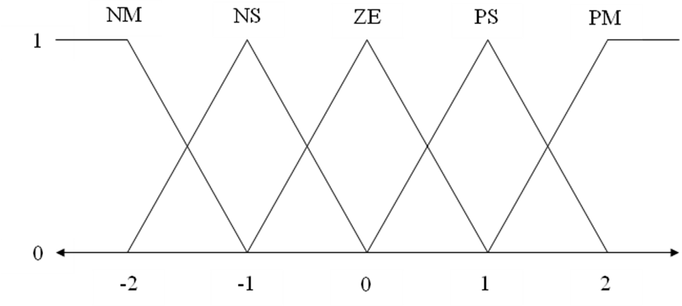

- (3 marks) Country is the most significant dominant attribute in the following table. Decide which attribute is the most significant dominant when Country = Europe.
Film | Country | Big Star | Genre | Success
Film 1 | USA | Yes | SF | True
Film 2 | USA | No | Comedy | False
Film 3 | USA | Yes | Comedy | True
Film 4 | Europe | No | Comedy | True
Film 5 | Europe | Yes | SF | False
Film 6 | Europe | Yes | Romance | False
Film 7 | Other | Yes | Comedy | False
Film 8 | Other | No | SF | False
Film 9 | Europe | Yes | Comedy | True
Film 10 | USA | Yes | Comedy | True

- (3 marks) Here is a training data set. Classify (2, 4) by using the 1-nearest neighbor algorithm.
X | Y | Class
1 | 1 | Blue
1 | 2 | Blue
2 | 1 | Blue
2 | 2 | Green
2 | 3 | Green
3 | 1 | Green
3 | 2 | Green
4 | 1 | Green
3 | 3 | Red
4 | 2 | Red
4 | 3 | Red

- (8 marks) Let’s consider a backpropagation neural network. This network has 4 nodes in the hidden layer and 2 nodes in the output layer. Let outputH be the array for the output values from the hidden layer to the output layer. Let outputO be the array for the output values from the output layer. Let the learning rate be 0.1. Let weightHO be the weight matrix between the hidden layer and the output layer. The expected values from the output layer are 0 and 1.

- (2 marks) Assuming the step function (not sigmoid function) with threshold 0.2 as the activation function for all the nodes in the output layer, write a program code to compute outputO. (Note that the step function outputs 0 or 1.)

- (2 marks) Write the program code to compute the delta values, deltaO, for the nodes in the output layer.

- (2 marks) Write the program code to compute the delta values, deltaH, for the nodes in the hidden layer.

- (2 marks) Write the program code to update the weight matrix weightHO.

- (2 marks) Identify which ones among Backpropagation networks, Hopfield networks, Kohonen Maps, BAM, and Hebbian networks, use supervised learning.

- (4 marks) Consider the next facts.
P(a) = 0.2 P(b) = 0.5 P(a|b) = 0.3 P(a|¬b) = 0.25
- Compute P(b∨a).

- Compute P(b|¬a)

- (6 marks) Consider the next joint probability distribution.
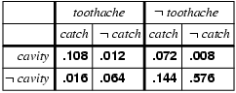

- (6 marks) Consider the next Bayesian network.
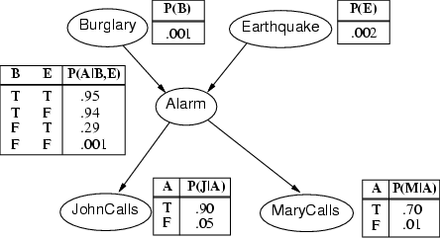
- Compute the probability that the alarm does not ring and there is burglary.

- Compute the probability that John calls, Mary does not call, the alarm rings, there is earthquake and there is no burglary.

- (5 marks) Consider naïve Bayes classifier with the following table.
X | d₁ | d₂ | d₃ | Classification
x₁ | 2 | 3 | 2 | A
x₂ | 4 | 1 | 2 | B
x₃ | 1 | 3 | 2 | A
x₄ | 2 | 4 | 3 | A
x₅ | 4 | 2 | 4 | B
x₆ | 2 | 1 | 3 | C
x₇ | 1 | 2 | 4 | A
x₈ | 2 | 3 | 3 | B
x₉ | 2 | 2 | 4 | A
x₁₀ | 3 | 3 | 2 | C
x₁₁ | 3 | 2 | 1 | A
x₁₂ | 1 | 2 | 1 | B
x₁₃ | 2 | 1 | 4 | A
x₁₄ | 4 | 3 | 4 | C
x₁₅ | 4 | 2 | 4 | A

- (2 marks) Compute P(A), P(B), P(C).

- (3 marks) What is the classification for (3, 1, 4)?

